AE 4361 – Assignment 4

1) a) Planet Lab's FLOCK 2P-6

Ground track:

3D Ground track:

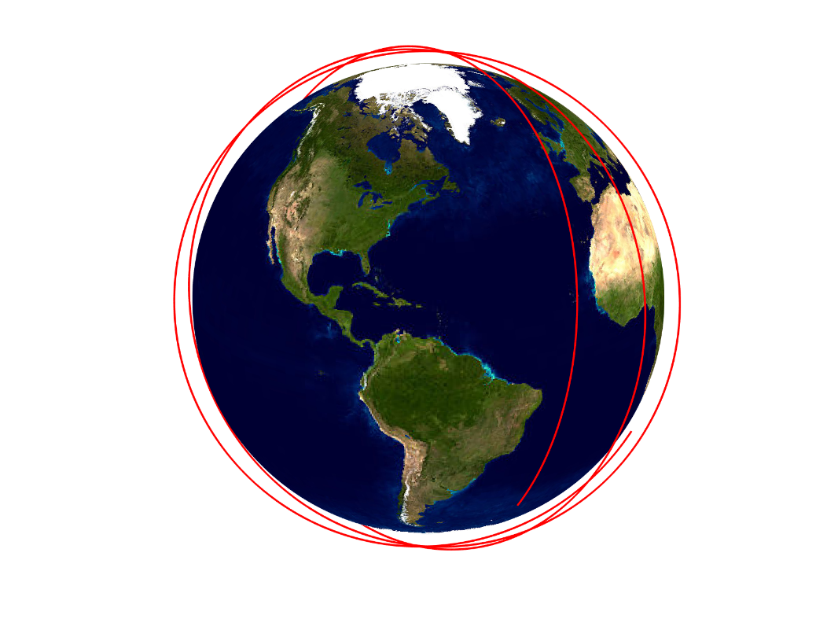

From the ground track above, we can see that the satellite seems to stay in high northern and southern latitudes, however, this is due to the orbit being Sun-Synchronous. Indeed, as we can see in the 3D ground track, the satellite goes over the north and south poles explicitly showing why the 2D track shows the satellite hovering in high northern and southern latitudes.

b) Molniya 2-9 Communication Satellite

Ground track:

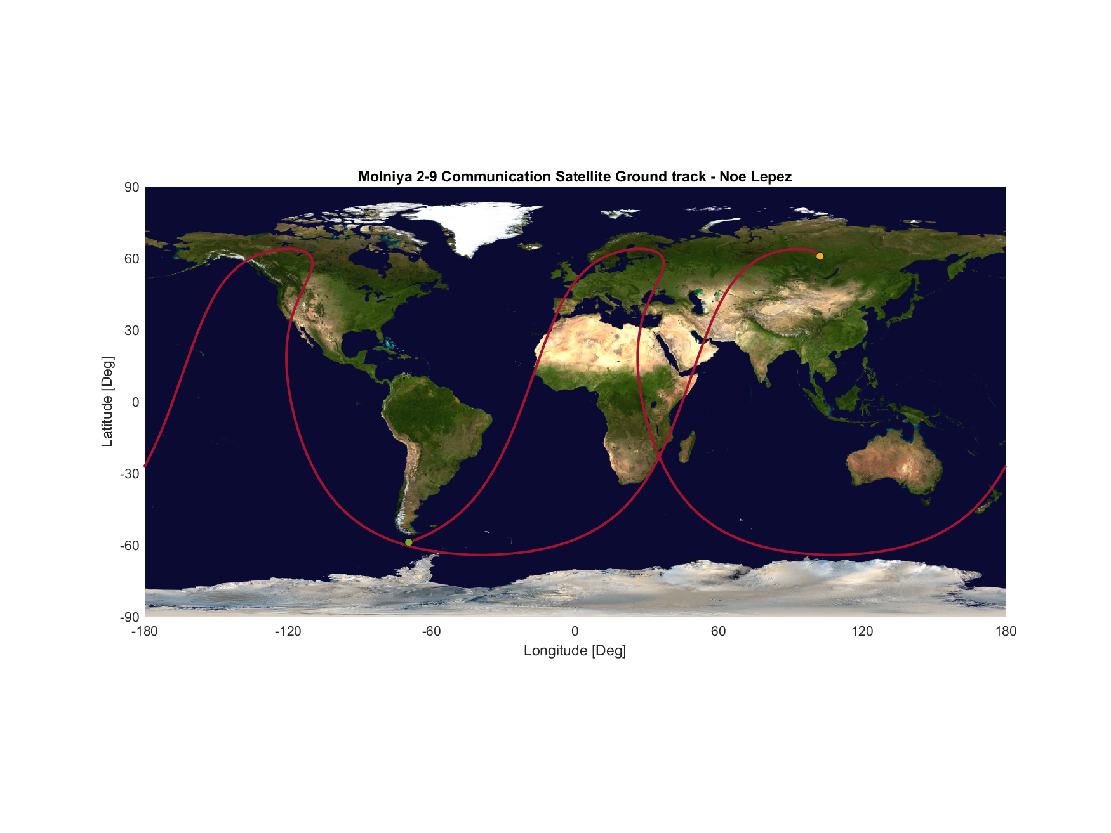

3D Ground track:

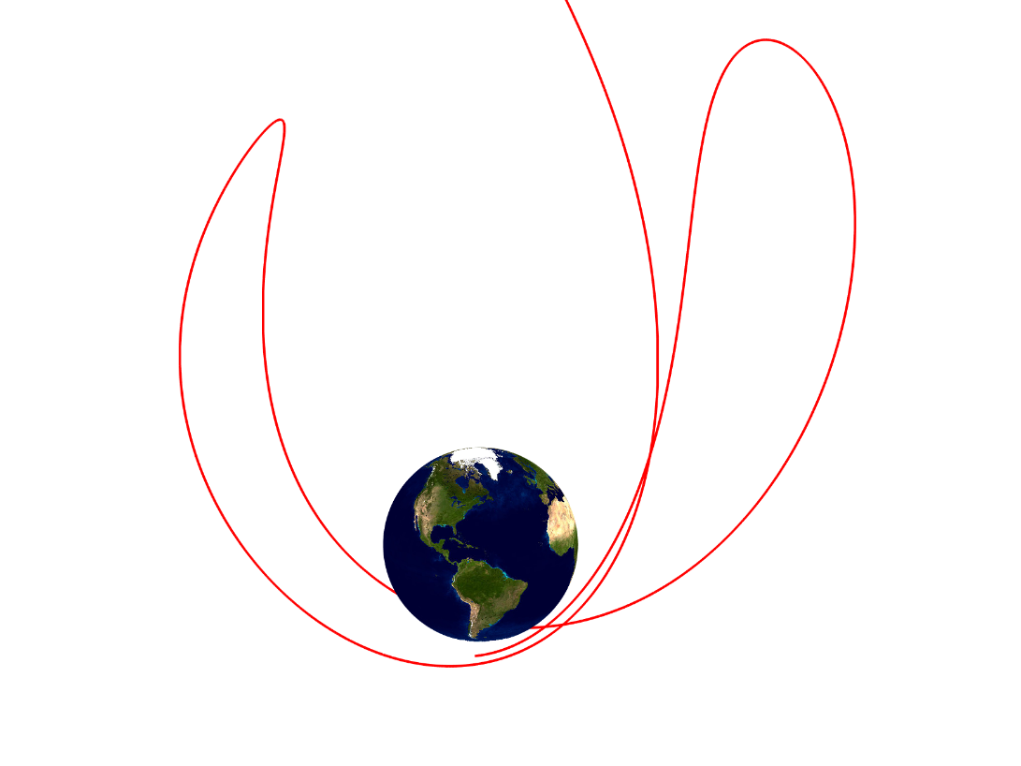

The Molniya 2-9 Communication Satellite seems to be following a wave-like pattern in its orbit from the 2d ground track, however, this is due to its slight eccentricity, which causes it to move in a retrograde motion when close to apogee, explaining why it seems to be moving westward at times. This is more apparent in the 3D ground track above.

See ‘orbital elements to lat/long/h’ & HW 4 workspace at the end of the document for code used.

2) a)

Code and output of calculations (code can also be found at the end of the document in HW 4 workspace, Q2 part a):

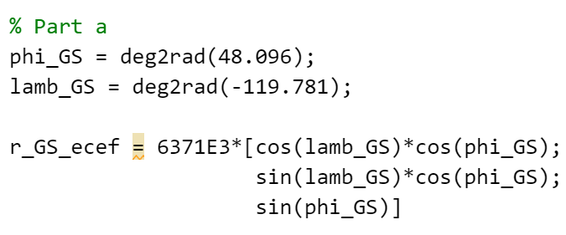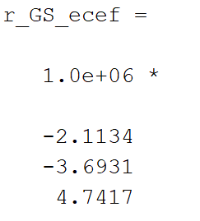

b)

Array output line 1 (251x4 array). See “Ground Station Visibility check” for source code.

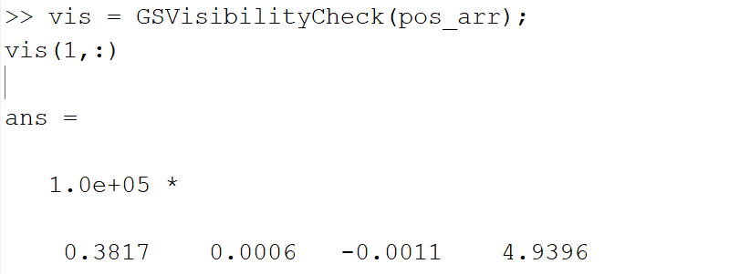

3) a)

Azimuth and elevation angles for the first line of the visibility matrix. See “Lat & Long to azimuth and elevation” for source code.

b)

